Term Project Final Report
C#으로 만든 영화예매 프로그램

Student: 이인규
Instructor: Doc. 남윤영 교수님
Course: 11365
Date: June. 11, 2023

Table Content

1. Introduction 3
2. Design 4
2.1 Source Data 4
2.2 Building Data Mart Process 7
3. Result 9
1. Introduction

C#의 Windows Form을 이용해 버스 예매 프로그램을 만들었습니다. 대부분의 방식은 같으나 저만의 방식으로 추가한 내용은 DataBase 대신 txt 파일을 이용해 동기화에 사용했습니다. 사용된 파일은 총 3개이며, 설명과 기능 및 형식은 다음과 같습니다.

BusInfo.txt
- 버스 정보가 담겨져 있다.
- 형식: 출발지;도착지;년도;월;일;시;분;버스회사;거리;시간;금액;예약되어있는좌석;좌석목록

ReserveInfo.txt
- 예약 목록이 담겨져있다.
- 형식: 출발지;도착지;시간;분;월;일;기본키;예약좌석;예약매수;전화번호;결제금액;전화번호

UserInfo.txt
- 회원 목록이 담겨져있다.
- 형식: 아이디;비밀번호;전화번호;이름;기본키;결제금액;쿠폰개수

2. Design

전체적인 디자인은 다음과 같습니다.

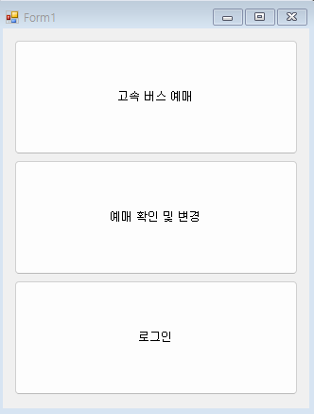
메인 화면입니다.

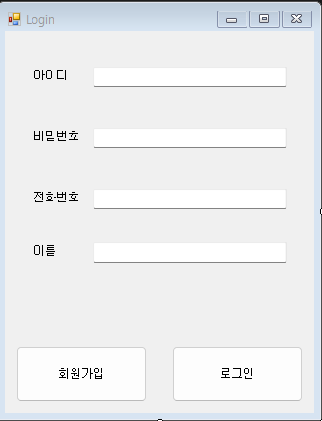
로그인 화면 입니다.

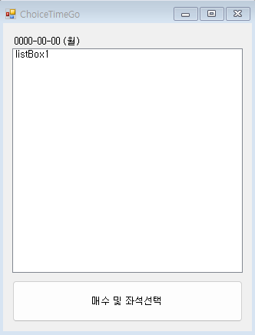
선택한 버스편의 시간을 선택하는 창입니다.

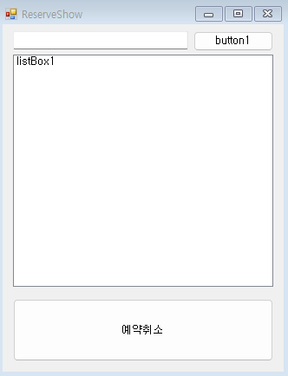
예약한 차편의 정보를 보여주는 화면입니다.

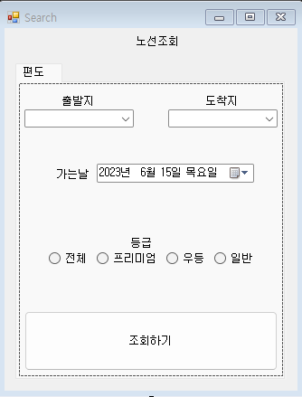
노선을 조회하게 해주는 화면입니다.

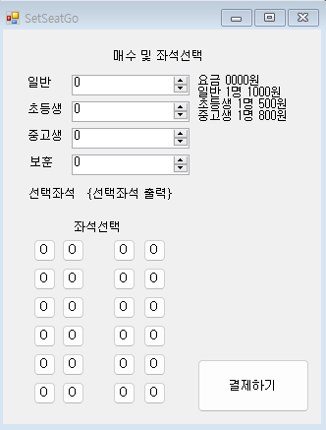
매수와 좌석을 선택하는 화면입니다.

2.1 Source Data

전체 소스 코드입니다.

Program.cs
using System;
using System.Collections.Generic;
using System.Linq;
using System.Threading.Tasks;
using System.Windows.Forms;

namespace Term
{
internal static class Program
{
/// <summary>
/// 해당 애플리케이션의 주 진입점입니다.
/// </summary>
[STAThread]
static void Main()
{
Application.EnableVisualStyles();
Application.SetCompatibleTextRenderingDefault(false);
Application.Run(new Form1());
}
}
}

ChoiceTimeGo.cs
using System;
using System.Collections.Generic;
using System.ComponentModel;
using System.Data;
using System.Drawing;
using System.Linq;
using System.Text;
using System.Threading.Tasks;
using System.Windows.Forms;
using static System.Windows.Forms.VisualStyles.VisualStyleElement;

namespace Term
{
public partial class ChoiceTimeGo : Form
{
public ChoiceTimeGo()
{
InitializeComponent();

if(Form1.loginInfo.name == "admin")
{
for (int i = 0; i < Form1.busesIdx; i++)
{
String start = Form1.buses[i].start;
String end = Form1.buses[i].end;
String year = Form1.buses[i].year;
String month = Form1.buses[i].month;
String day = Form1.buses[i].day;
String hour = Form1.buses[i].hour;
String minute = Form1.buses[i].minute;
String type = Form1.buses[i].type;
String company = Form1.buses[i].company;
String seats = " 잔여: " + (24 - Form1.buses[i].seatNum) + "/24";
String charge = "일반요금:" + Form1.buses[i].charge.ToString() + "원";
String distance = "거리: " + Form1.buses[i].distance.ToString();
String times = Form1.buses[i].times;

label2.Text = year + "-" + month + "-" + day + " " + charge + " " + distance + " " + times;

String output = start + "->" + end + " " + hour + ":" + minute + " " + type + " " + company + seats;
listBox1.Items.Add(output);
}
}
else
{
if(Form1.tempbusidx == 0)
{
MessageBox.Show("해당되는 차편이 없습니다.\n다시 검색해주세요.");
}

for (int i = 0; i < Form1.tempbusidx; i++)
{
String start = Form1.Tempbuses[i].start;
String end = Form1.Tempbuses[i].end;
String year = Form1.Tempbuses[i].year;
String month = Form1.Tempbuses[i].month;
String day = Form1.Tempbuses[i].day;
String hour = Form1.Tempbuses[i].hour;
String minute = Form1.Tempbuses[i].minute;
String type = Form1.Tempbuses[i].type;
String company = Form1.Tempbuses[i].company;
String seats = " 잔여: " + (24 - Form1.Tempbuses[i].seatNum) + "/24";
String charge = "일반요금:" + Form1.Tempbuses[i].charge.ToString() + "원";
String distance = "거리: " + Form1.Tempbuses[i].distance.ToString();
String times = Form1.Tempbuses[i].times;

label2.Text = year + "-" + month + "-" + day + " " + charge + " " + distance + " " + times;

String output = start + "->" + end + " " + hour + ":" + minute + " " + type + " " + company + seats;
listBox1.Items.Add(output);
}
}

}

private void button1_Click(object sender, EventArgs e)
{
if(listBox1.SelectedIndex != -1)
{
Form1.selectOne = Form1.Tempbuses[listBox1.SelectedIndex];
this.Visible = false;
SetSeatGo setseatgo = new SetSeatGo();
setseatgo.Show();
}
else
{
MessageBox.Show("원하시는 차편을 선택해주세요.");
}
}
}
}

Form1.cs
using System;
using System.IO;
using System.Security.Policy;
using System.Windows.Forms;

namespace Term
{
public partial class Form1 : Form
{
static public bool loginChecker = false;
static public UserForm[] users = new UserForm[100];
static public int userIdx = 0;
static public UserForm loginInfo;
static public BusForm[] buses = new BusForm[500];
static public int busesIdx = 0;
static public BusForm selectForm;
static public BusForm[] Tempbuses = new BusForm[500];
static public int tempbusidx = 0;
static public BusForm selectOne;
static public String people;
static public ChoiceForm[] seats_list;
static public int seatsIdx = 0;
static public String seat_output;
static public int sum;
static public BusForm[] reserves = new BusForm[500];
static public int reservesIdx = 0;
static public ReserveForm[] reserveList = new ReserveForm[500];
static public int reserveListIdx = 0;

public Form1()
{
InitializeComponent();

StreamReader sr = new StreamReader("./ReserveInfo.txt");
String line = sr.ReadLine();

while (line != null)
{
String start = line.Split(';')[0];
String end = line.Split(';')[1];
String hour = line.Split(';')[2];
String minute = line.Split(';')[3];
String month = line.Split(';')[4];
String day = line.Split(';')[5];
int idxx = Int32.Parse(line.Split(';')[6]);
String seats = line.Split(';')[7];
int seatIdx = Int32.Parse(line.Split(';')[8]);
String number = line.Split(';')[9];
int pay = Int32.Parse(line.Split(';')[10]);
String phone = line.Split(';')[11];
ChoiceForm[] cform = new ChoiceForm[24];
int cidx = 0;

for (int i = 0; i < seatIdx * 2; i += 2)
{
int row = seats[i] - '0';
int col = seats[i + 1] - '0';
cform[cidx++] = new ChoiceForm(row, col);
}

reserveList[reserveListIdx++] = new ReserveForm(start, end, hour, minute, month, day, idxx, cform, cidx, phone, pay);
line = sr.ReadLine();
}
sr.Close();

sr = new StreamReader("./UserInfo.txt");
line = sr.ReadLine();

while (line != null)
{
String id = line.Split(';')[0];
String pw = line.Split(';')[1];
String phone = line.Split(';')[2];
String name = line.Split(';')[3];
int discount = Int32.Parse(line.Split(';')[4]);
int pay = Int32.Parse(line.Split(';')[5]);

users[userIdx++] = new UserForm(id, pw, phone, name, discount, pay, userIdx - 1);
line = sr.ReadLine();
}
sr.Close();

sr = new StreamReader("./BusInfo.txt");
line = sr.ReadLine();

while (line != null)
{
String start = line.Split(';')[0];
String end = line.Split(';')[1];
String year = line.Split(';')[2];
String month = line.Split(';')[3];
String day = line.Split(';')[4];
String hour = line.Split(';')[5];
String minute = line.Split(';')[6];
String type = line.Split(';')[7];
String company = line.Split(';')[8];
String distance = line.Split(';')[9];
String times = line.Split(';')[10];
int charge = Int32.Parse(line.Split(';')[11]);
int[,] temp = new int[6, 4];
int seatNum = Int32.Parse(line.Split(';')[12]);
String seats = line.Split(';')[13];

for(int i=0; i<6; i++)
{
for(int j=0; j<4; j++)
{
temp[i,j] = 0;
}
}

for(int i=0; i<seatNum*2; i+=2)
{
int row = seats[i] - '0';
int col = seats[i+1] - '0';
temp[row,col] = 1;
}

buses[busesIdx++] = new BusForm(start, end, year, month, day, hour, minute, type, company, distance, times, charge, seatNum, temp, busesIdx-1);
line = sr.ReadLine();
}
sr.Close();
}

private void button3_Click(object sender, EventArgs e) // 로그인
{
if (loginChecker)
{
MessageBox.Show("로그인 되어있습니다.");
}
else
{
Login login = new Login();
login.Show();
}
}

private void button2_Click(object sender, EventArgs e) // 예매 확인
{
ReserveShow reserveShow = new ReserveShow();
reserveShow.Show();
}

private void button1_Click(object sender, EventArgs e) // 고속 버스 예매
{
Search search = new Search();
search.Show();
}
}

public class ReserveForm
{
public String start;
public String end;
public String hour;
public String minute;
public String month;
public String day;
public int idx;
public ChoiceForm[] seats; // Form1.seatsIdx 같이 있음
public int seatsIdx;
public String phone;
public int pay;

public ReserveForm(string start, string end, string hour, string minute, string month, string day, int idx, ChoiceForm[] seats, int seatsIdx, string phone, int pay)
{
this.start = start;
this.end = end;
this.hour = hour;
this.minute = minute;
this.month = month;
this.day = day;
this.idx = idx;
this.seats = seats;
this.seatsIdx = seatsIdx;
this.phone = phone;
this.pay = pay;
}
}

public class ChoiceForm
{
public int x;
public int y;

public ChoiceForm(int x, int y)
{
this.x = x;
this.y = y;
}
}

public class UserForm
{
public String id;
public String pw;
public String phone;
public String name;
public int discount;
public int pay;
public int idx;

public UserForm(String id, String pw, String phone, string name, int discount, int pay, int idx)
{
this.id = id;
this.pw = pw;
this.phone = phone;
this.name = name;
this.discount = discount;
this.pay = pay;
this.idx = idx;
}
}

public class BusForm
{
public String start;
public String end;
public String year;
public String month;
public String day;
public String hour;
public String minute;
public String type;
public String company;
public int seatNum;
public int[,] seat_state;
public String distance;
public String times;
public int charge;
public int idx;

public BusForm(string start, string end, string year, string month, string day, string hour, string minute, string type, string company, String distance, String times, int charge, int seatNum, int[,] seat_state, int idx)
{
this.start = start;
this.end = end;
this.year = year;
this.month = month;
this.day = day;
this.hour = hour;
this.minute = minute;
this.type = type;
this.company = company;
this.distance = distance;
this.times = times;
this.charge = charge;
this.seatNum = seatNum;
this.seat_state = seat_state;
this.idx = idx;
}
}
}

Login.cs
using System;
using System.Collections.Generic;
using System.ComponentModel;
using System.Data;
using System.Drawing;
using System.IO;
using System.Linq;
using System.Text;
using System.Threading.Tasks;
using System.Windows.Forms;

namespace Term
{
public partial class Login : Form
{
public Login()
{
InitializeComponent();
}

private void button1_Click(object sender, EventArgs e)
{
String id = dkdlel.Text;
String pw = qlalfqjsgh.Text;
String phone = wjsghkqjsgh.Text;
String name = textBox1.Text;
bool exist = false;

if (id == "" || pw == "" || phone == "" || name == "")
{
MessageBox.Show("공백이 있습니다!");
}
else
{
for(int i=0; i<Form1.userIdx; i++)
{
if(id == Form1.users[i].id || phone == Form1.users[i].phone || Form1.users[i].name == name)
{
exist = true;
break;
}
}

if (exist)
{
MessageBox.Show("이미 존재하는 회원입니다.");
}
else
{
Form1.users[Form1.userIdx++] = new UserForm(id, pw, phone, name, 1, 0, Form1.userIdx - 1);
MessageBox.Show("회원가입 되었습니다.\n할인 쿠폰 1장이 증정되었습니다.");

try
{
StreamWriter sw = new StreamWriter("./UserInfo.txt");

for(int i=0; i<Form1.userIdx; i++)
{
String temp = Form1.users[i].id + ";" + Form1.users[i].pw + ";" + Form1.users[i].phone + ";" + Form1.users[i].name + ";" + Form1.users[i].discount + ";" + Form1.users[i].pay + ";" + Form1.users[i].idx;
sw.WriteLine(temp);
}
sw.Close();
}
catch(Exception ex){}

this.Close();
}
}
}

private void button2_Click(object sender, EventArgs e)
{
String id = dkdlel.Text;
String pw = qlalfqjsgh.Text;
String phone = wjsghkqjsgh.Text;
String name = textBox1.Text;
bool exist = false;
int counts = 0;
int idx = 0;
int pay = 0;

for (int i = 0; i < Form1.userIdx; i++)
{
if (id == Form1.users[i].id && pw == Form1.users[i].pw && phone == Form1.users[i].phone)
{
exist = true;
counts = Form1.users[i].discount;
pay = Form1.users[i].pay;
idx = i;
break;
}
}

if (exist)
{
Form1.loginChecker = true;
MessageBox.Show("로그인 되었습니다!");
Form1.loginInfo = new UserForm(id, pw, phone, name, counts, pay ,idx);
this.Close();
}
else
{
MessageBox.Show("존재하지 않는 회원입니다.");
}
}
}
}

ReserveShow.cs
using System;
using System.Collections.Generic;
using System.ComponentModel;
using System.Data;
using System.Drawing;
using System.Linq;
using System.Text;
using System.Threading.Tasks;
using System.Windows.Forms;
using static System.Windows.Forms.VisualStyles.VisualStyleElement;

namespace Term
{
public partial class ReserveShow : Form
{
public ReserveShow()
{
InitializeComponent();

button1.Text = "번호로 검색";

if(Form1.loginInfo.name == "admin")
{
listBox1.Items.Clear();

int pays = 0;

for (int i = 0; i < Form1.reserveListIdx; i++)
{
ReserveForm rform = Form1.reserveList[i];
String start = rform.start;
String end = rform.end;
String hour = rform.hour;
String minute = rform.minute;
String month = rform.month;
String day = rform.day;
String seat_output = "";
String phones = rform.phone;
int idx = rform.idx;

pays += rform.pay;

for (int j = 0; j < Form1.seatsIdx; j++)
{
seat_output += "(" + Form1.reserveList[i].seats[j].x + "," + Form1.reserveList[i].seats[j].y + ") ";
}
String adds = idx + "|출발: " + start + " 도착: " + end + " " + hour + ":" + minute + " " + month + "/" + day + " " + seat_output;
listBox1.Items.Add(adds);
}

textBox1.Text = "현재 판매 금액: " + pays;
}
}

private void button1_Click(object sender, EventArgs e)
{
String phone = textBox1.Text;
listBox1.Items.Clear();

for(int i=0; i<Form1.reserveListIdx; i++)
{
ReserveForm rform = Form1.reserveList[i];
String start = rform.start;
String end = rform.end;
String hour = rform.hour;
String minute = rform.minute;
String month = rform.month;
String day = rform.day;
String seat_output = "";
String phones = rform.phone;
int idx = rform.idx;

for(int j=0; j<Form1.seatsIdx; j++)
{
seat_output += "(" + Form1.reserveList[i].seats[j].x + "," + Form1.reserveList[i].seats[j].y + ") ";
}

if(phone == phones)
{
String adds = idx + "|출발: " + start + " 도착: " + end + " " + hour + ":" + minute + " " + month + "/" + day + " " + seat_output;
listBox1.Items.Add(adds);
}
}
}

private void button2_Click(object sender, EventArgs e)
{
if (listBox1.SelectedItem != null)
{
String choice = listBox1.SelectedItem.ToString().Split('|')[0];
int idx = Int32.Parse(choice);

ReserveForm temp = Form1.reserveList[idx];
Form1.reserveList[idx] = Form1.reserveList[Form1.reserveListIdx];
Form1.reserveList[Form1.reservesIdx] = temp;
Form1.reserveListIdx = Form1.reserveListIdx - 1;

MessageBox.Show("예약 취소 되었습니다.");

this.Close();
}
else
{
MessageBox.Show("예약 취소할 항목을 골라주세요.");
}
}

private void listBox1_SelectedIndexChanged(object sender, EventArgs e)
{
}
}
}

Search.cs
using System;
using System.Collections.Generic;
using System.ComponentModel;
using System.Data;
using System.Drawing;
using System.Linq;
using System.Text;
using System.Threading.Tasks;
using System.Windows.Forms;

namespace Term
{
public partial class Search : Form
{
public Search()
{
InitializeComponent();
}

private void button1_Click(object sender, EventArgs e)
{
if (comboBox1.SelectedItem != null && comboBox2.SelectedItem != null)
{
String goLocate = comboBox1.SelectedItem.ToString();
String endLocate = comboBox2.SelectedItem.ToString();
String date = dateTimePicker1.Value.ToString("yyyy;MM;dd");
String grade;

String year = date.Split(';')[0];
String month = date.Split(';')[1];
String day = date.Split(';')[2];

if (radioButton4.Checked)
{
grade = radioButton4.Text;
}
else if (radioButton2.Checked)
{
grade = radioButton2.Text;
}
else if (radioButton3.Checked)
{
grade = radioButton3.Text;
}
else
{
grade = radioButton1.Text;
}

Form1.tempbusidx = 0;

for (int i = 0; i < Form1.busesIdx; i++)
{
bool one = goLocate == Form1.buses[i].start;
bool two = endLocate == Form1.buses[i].end;
bool three = year == Form1.buses[i].year;
bool four = month == Form1.buses[i].month;
bool five = day == Form1.buses[i].day;
bool six = grade == Form1.buses[i].type;

Console.WriteLine(grade);

if (grade == "전체")
{
six = true;
}

if (one && two && three && four && five && six)
{
Form1.Tempbuses[Form1.tempbusidx++] = new BusForm(goLocate, endLocate, year, month, day, Form1.buses[i].hour, Form1.buses[i].minute, Form1.buses[i].type, Form1.buses[i].company, Form1.buses[i].distance, Form1.buses[i].times, Form1.buses[i].charge, Form1.buses[i].seatNum, Form1.buses[i].seat_state, Form1.tempbusidx - 1);
}
}

this.Visible = false;
ChoiceTimeGo choicetimego = new ChoiceTimeGo();
choicetimego.Show();
}
else
{
if(Form1.loginInfo.name == "admin")
{
this.Visible = false;
ChoiceTimeGo choicetimego = new ChoiceTimeGo();
choicetimego.Show();
}
else
{
MessageBox.Show("공백이 있습니다!");
}
}
}
}
}

SetSeatGo.cs
using System;
using System.Windows.Forms;

namespace Term
{
public partial class SetSeatGo : Form
{
Button[,] seats = new Button[6, 4];
int sum = 0;
int number = 0;
int clicked = 0;
ChoiceForm[] choices = new ChoiceForm[24];
int choiceidx = 0;

public SetSeatGo()
{
InitializeComponent();

label6.Text = "";
int count = 23;
foreach (Control b in this.Controls)
{
if (b is Button)
{
if (b.Text == "O" || b.Text == "X")
{
seats[count/4, count%4] = (Button)b;
seats[count/4, count%4].Click += MyNewButton_Click;
count--;
}
}
}

label7.Text = "요금 " + sum + "원\n" + "일반 1명 " + Form1.selectOne.charge + "원\n초등생 1명 " + Form1.selectOne.charge * 0.9 + "원\n중고생 1명 " + Form1.selectOne.charge * 0.8 + "원" + "\n보훈 1명 " + Form1.selectOne.charge * 0.7 + "원";

for(int i=0; i<6; i++)
{
for(int j=0; j<4; j++)
{
if (Form1.selectOne.seat_state[i,j] == 1)
{
seats[i, j].Enabled = false;
seats[i, j].Text = "X";
}
}
}
}

private void MyNewButton_Click(object sender, EventArgs e)
{
Button clickedButton = (Button)sender;

if(clicked < number)
{
for(int i=0; i<6; i++)
{
for(int j=0; j<4; j++)
{
if (seats[i,j] == clickedButton)
{
choices[choiceidx++] = new ChoiceForm(i, j);
label6.Text += "(" + i + "," + j + ") ";
}
}
}
clickedButton.Enabled = false;
clicked += 1;
}
}

private void numericUpDown1_ValueChanged(object sender, EventArgs e)
{
number = Int32.Parse(numericUpDown1.Value.ToString());
number += Int32.Parse(numericUpDown2.Value.ToString());
number += Int32.Parse(numericUpDown3.Value.ToString());
number += Int32.Parse(numericUpDown4.Value.ToString());

int sum1 = Int32.Parse(numericUpDown1.Value.ToString()) * Form1.selectOne.charge;
int sum2 = Int32.Parse(numericUpDown2.Value.ToString()) * Form1.selectOne.charge;
int sum3 = Int32.Parse(numericUpDown3.Value.ToString()) * Form1.selectOne.charge;
int sum4 = Int32.Parse(numericUpDown4.Value.ToString()) * Form1.selectOne.charge;

sum = sum1 + (int)(sum2 * 0.9) + (int)(sum3 * 0.8) + (int)(sum4 * 0.7);

label7.Text = "요금 " + sum + "원\n" + "일반 1명 " + Form1.selectOne.charge + "원\n초등생 1명 " + Form1.selectOne.charge * 0.9 + "원\n중고생 1명 " + Form1.selectOne.charge * 0.8 + "원" + "\n보훈 1명 " + Form1.selectOne.charge * 0.7 + "원";
}

private void numericUpDown2_ValueChanged(object sender, EventArgs e)
{
number = Int32.Parse(numericUpDown1.Value.ToString());
number += Int32.Parse(numericUpDown2.Value.ToString());
number += Int32.Parse(numericUpDown3.Value.ToString());
number += Int32.Parse(numericUpDown4.Value.ToString());

int sum1 = Int32.Parse(numericUpDown1.Value.ToString()) * Form1.selectOne.charge;
int sum2 = Int32.Parse(numericUpDown2.Value.ToString()) * Form1.selectOne.charge;
int sum3 = Int32.Parse(numericUpDown3.Value.ToString()) * Form1.selectOne.charge;
int sum4 = Int32.Parse(numericUpDown4.Value.ToString()) * Form1.selectOne.charge;

sum = sum1 + (int)(sum2 * 0.9) + (int)(sum3 * 0.8) + (int)(sum4 * 0.7);

label7.Text = "요금 " + sum + "원\n" + "일반 1명 " + Form1.selectOne.charge + "원\n초등생 1명 " + Form1.selectOne.charge * 0.9 + "원\n중고생 1명 " + Form1.selectOne.charge * 0.8 + "원" + "\n보훈 1명 " + Form1.selectOne.charge * 0.7 + "원";
}

private void numericUpDown3_ValueChanged(object sender, EventArgs e)
{
number = Int32.Parse(numericUpDown1.Value.ToString());
number += Int32.Parse(numericUpDown2.Value.ToString());
number += Int32.Parse(numericUpDown3.Value.ToString());
number += Int32.Parse(numericUpDown4.Value.ToString());

int sum1 = Int32.Parse(numericUpDown1.Value.ToString()) * Form1.selectOne.charge;
int sum2 = Int32.Parse(numericUpDown2.Value.ToString()) * Form1.selectOne.charge;
int sum3 = Int32.Parse(numericUpDown3.Value.ToString()) * Form1.selectOne.charge;
int sum4 = Int32.Parse(numericUpDown4.Value.ToString()) * Form1.selectOne.charge;

sum = sum1 + (int)(sum2 * 0.9) + (int)(sum3 * 0.8) + (int)(sum4 * 0.7);

label7.Text = "요금 " + sum + "원\n" + "일반 1명 " + Form1.selectOne.charge + "원\n초등생 1명 " + Form1.selectOne.charge * 0.9 + "원\n중고생 1명 " + Form1.selectOne.charge * 0.8 + "원" + "\n보훈 1명 " + Form1.selectOne.charge * 0.7 + "원";
}

private void numericUpDown4_ValueChanged(object sender, EventArgs e)
{
number = Int32.Parse(numericUpDown1.Value.ToString());
number += Int32.Parse(numericUpDown2.Value.ToString());
number += Int32.Parse(numericUpDown3.Value.ToString());
number += Int32.Parse(numericUpDown4.Value.ToString());

int sum1 = Int32.Parse(numericUpDown1.Value.ToString()) * Form1.selectOne.charge;
int sum2 = Int32.Parse(numericUpDown2.Value.ToString()) * Form1.selectOne.charge;
int sum3 = Int32.Parse(numericUpDown3.Value.ToString()) * Form1.selectOne.charge;
int sum4 = Int32.Parse(numericUpDown4.Value.ToString()) * Form1.selectOne.charge;

sum = sum1 + (int)(sum2 * 0.9) + (int)(sum3 * 0.8) + (int)(sum4 * 0.7);

label7.Text = "요금 " + sum + "원\n" + "일반 1명 " + Form1.selectOne.charge + "원\n초등생 1명 " + Form1.selectOne.charge * 0.9 + "원\n중고생 1명 " + Form1.selectOne.charge * 0.8 + "원" + "\n보훈 1명 " + Form1.selectOne.charge * 0.7 + "원";
}

private void button26_Click(object sender, EventArgs e)
{
if(clicked == number){
Form1.people = "일반 " + Int32.Parse(numericUpDown1.Value.ToString()) + "명\n";
Form1.people += "초등생 " + Int32.Parse(numericUpDown2.Value.ToString()) + "명\n";
Form1.people += "중등생 " + Int32.Parse(numericUpDown3.Value.ToString()) + "명\n";
Form1.people += "보훈 " + Int32.Parse(numericUpDown4.Value.ToString()) + "명";

Form1.seat_output = label6.Text;
Form1.seats_list = choices;
Form1.seatsIdx = choiceidx;
Form1.sum = sum;

if (Form1.loginChecker)
{
this.Close();
Summary summary = new Summary();
summary.Show();
}
else
{
MessageBox.Show("로그인이 필요한 서비스입니다.");
Login login = new Login();
login.Show();
}
}
else
{
MessageBox.Show("선택한 좌석과 인원이 맞지 않습니다.\n다시 확인해주세요.");
}
}
}
}

Summary.cs
using System;
using System.Collections.Generic;
using System.ComponentModel;
using System.Data;
using System.Drawing;
using System.IO;
using System.Linq;
using System.Text;
using System.Threading.Tasks;
using System.Windows.Forms;

namespace Term
{

public partial class Summary : Form
{
int sum = Form1.sum;
double discount = 0;
BusForm one = Form1.selectOne;

public Summary()
{
InitializeComponent();

label1.Text = one.year + ". " + one.month + ". " + one.day + ". " + one.hour + ":" + one.minute;
label2.Text = "출발: " + one.start;
label3.Text = "도착: " + one.end;
label4.Text = "고속사: " + one.company;
label5.Text = "등급: " + one.type;
label6.Text = "매수: " + Form1.people;
label7.Text = "좌석: " + Form1.seat_output;
checkBox1.Text = "멤버쉽 여부";
checkBox2.Text = "할인쿠폰 여부 (" + Form1.loginInfo.discount + "장 보유)";
label8.Text = "예매 금액: " + sum + "원";
label9.Text = "할인 금액: 0원";
label10.Text = "총 결제 금액: ";
button1.Text = "결제하기";
}

private void checkBox1_CheckedChanged(object sender, EventArgs e)
{
discount = 0.0;

if (checkBox1.Checked)
{
discount += 0.1;
}
if (checkBox2.Checked && Form1.loginInfo.discount > 0)
{
discount += 0.1;
}

label9.Text = "할인 금액: " + (sum * discount) + "원";
label10.Text = "총 결제 금액: " + (sum - (sum * discount)) + "원";
}

private void checkBox2_CheckedChanged(object sender, EventArgs e)
{
discount = 0.0;

if (checkBox1.Checked)
{
discount += 0.1;
}
if (checkBox2.Checked && Form1.loginInfo.discount > 0)
{
discount += 0.1;
}

label9.Text = "할인 금액: " + (sum * discount) + "원";
label10.Text = "총 결제 금액: " + (sum - (sum * discount)) + "원";
}

private void button1_Click(object sender, EventArgs e)
{
String start = one.start;
String end = one.end;
String hour = one.hour;
String minute = one.minute;
String month = one.month;
String day = one.day;
int idx = one.idx;
ChoiceForm[] seats = Form1.seats_list; // Form1.seatsIdx 같이 있음
String phone = Form1.loginInfo.phone;
int pay = (int)(sum - (sum * discount));
Form1.loginInfo.discount--;

Form1.reserveList[Form1.reserveListIdx++] = new ReserveForm(start, end, hour, minute, month, day, idx, seats, Form1.seatsIdx, phone, pay);

try
{
StreamWriter sw = new StreamWriter("./ReserveInfo.txt");

for (int i = 0; i < Form1.reserveListIdx; i++)
{
ReserveForm fom = Form1.reserveList[i];

int lenj = Form1.seatsIdx;
String output = "";
for(int j=0; j<lenj; j++)
{
output += fom.seats[j].x + "" + fom.seats[j].y + "";
}

String temp = fom.start + ";" + fom.end + ";" + fom.hour + ";" + fom.minute + ";" + fom.month + ";" + fom.day + ";" + fom.idx + ";" + output + ";" + fom.seatsIdx + ";" + fom.phone + ";" + fom.pay + ";" + fom.phone;
sw.WriteLine(temp);
}
sw.Close();
}
catch (Exception ex) { }

try
{
StreamWriter sw = new StreamWriter("./UserInfo.txt");

for (int i = 0; i < Form1.userIdx; i++)
{
if (Form1.users[i].name == Form1.loginInfo.name)
{
Form1.users[i].pay += (int)(sum - (sum * discount));
Form1.users[i].discount += 1;
String temp = Form1.users[i].id + ";" + Form1.users[i].pw + ";" + Form1.users[i].phone + ";" + Form1.users[i].name + ";" + Form1.users[i].discount + ";" + Form1.users[i].pay + ";" + Form1.users[i].idx;
sw.WriteLine(temp);
}
else
{
String temp = Form1.users[i].id + ";" + Form1.users[i].pw + ";" + Form1.users[i].phone + ";" + Form1.users[i].name + ";" + Form1.users[i].discount + ";" + Form1.users[i].pay + ";" + Form1.users[i].idx;
sw.WriteLine(temp);
}
}
sw.Close();
}
catch (Exception ex) { }

MessageBox.Show("예약 완료 되었습니다.");
this.Close();
}
}
}

2. 2 Building Data Mart Process

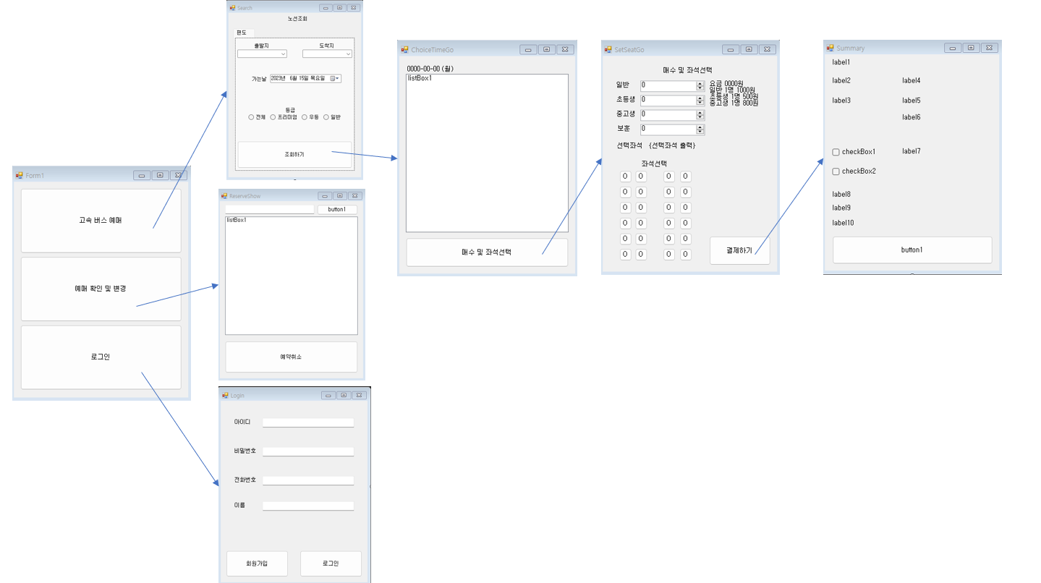
3. Result

